Laboratorio # 12

Descargamos XAMPP

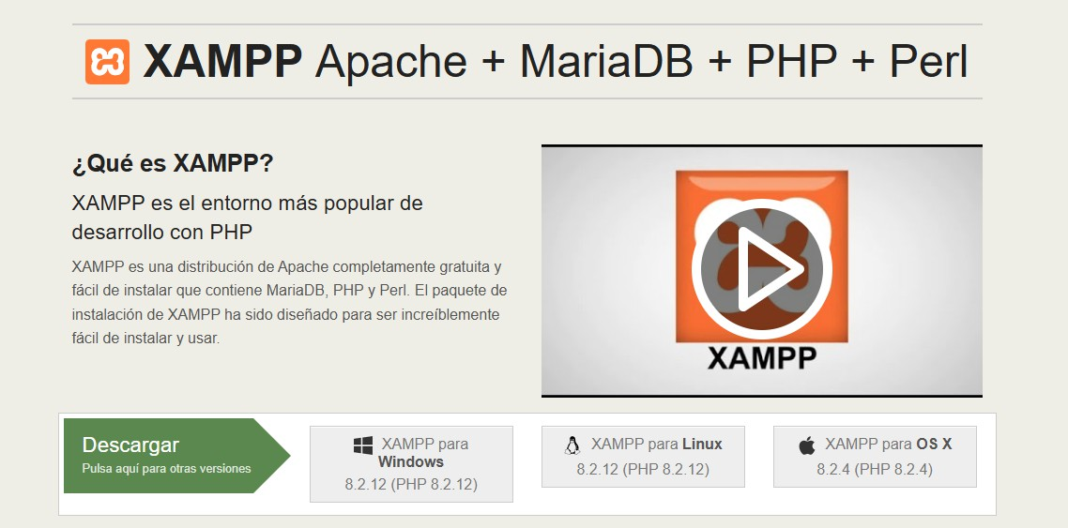

Abrimos XAMPP

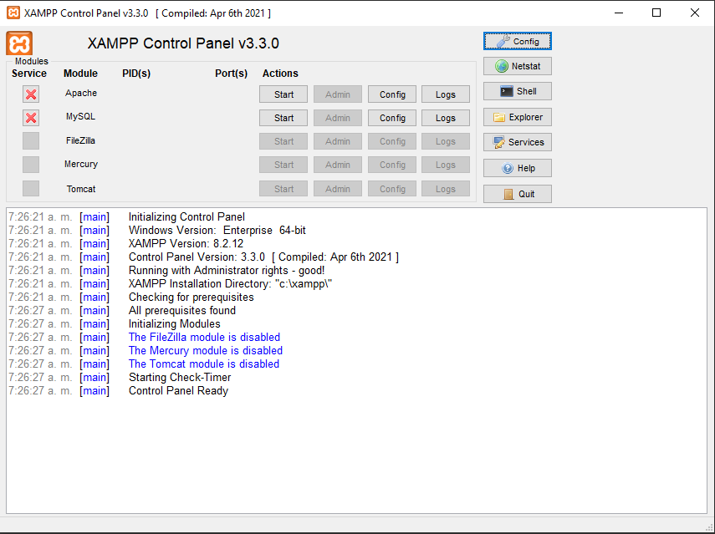

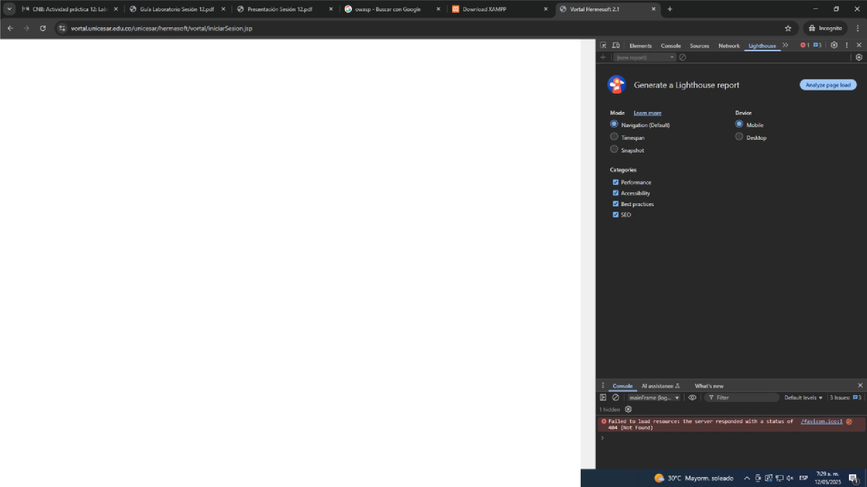

.Bl

-ErNii!l\lllCdWlIlIIl)6, lllt'IDl l'allllltOJO!!IHliUlN_l,HOH- lll•illllltl _C)I rOltlf r..Jt!O"IIIIH

CMll:lffHotllll!WlriC\lllllti-11

.c.-.-...,-, '-IA.Z)

- -io-"

5ili-,111oe!IIIDOt: •{I •.• 1,1,r;1111· 'II ;:_9

**Wk:f-W**

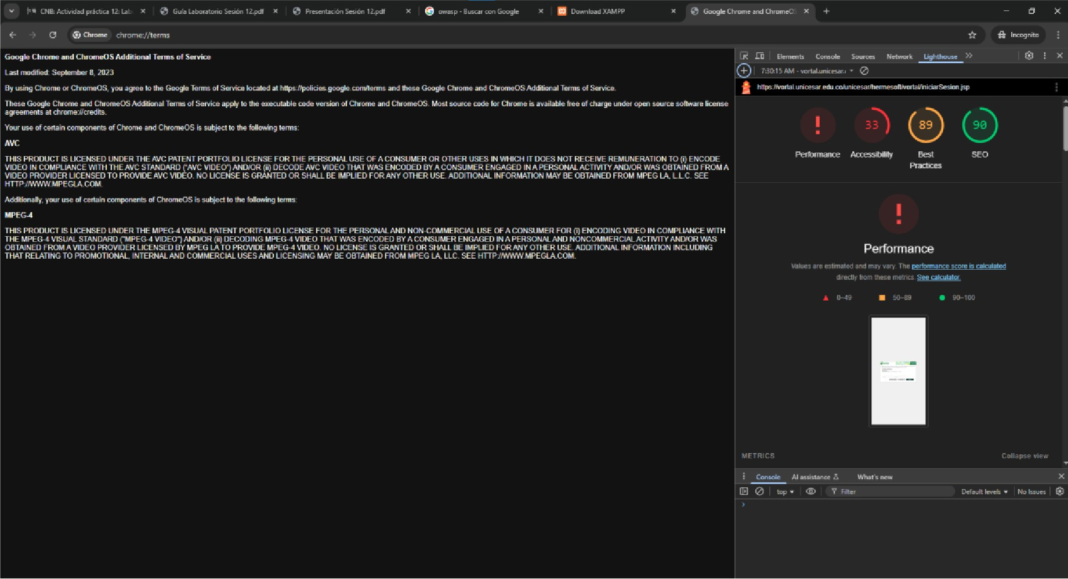

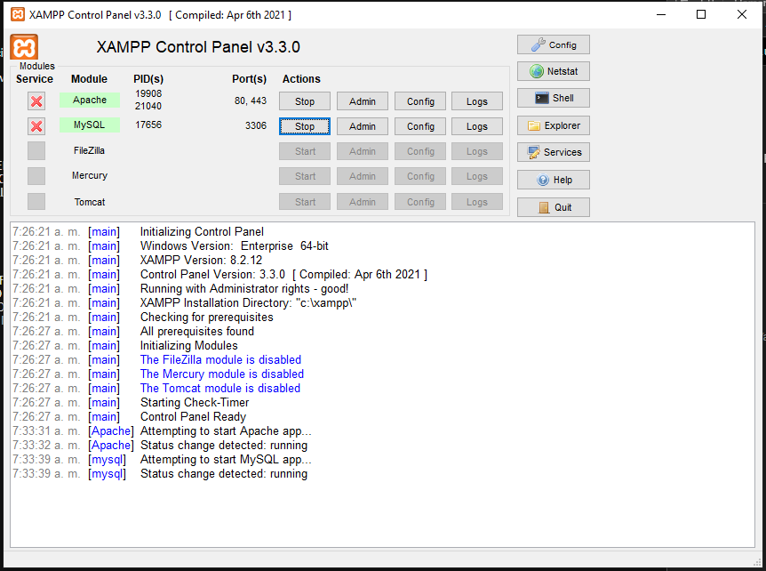

Damos click en admin

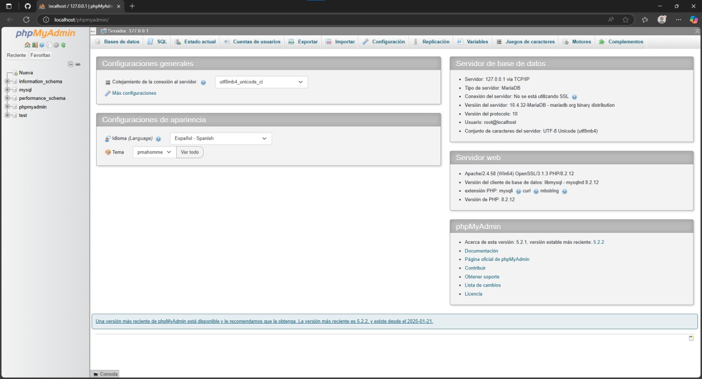

i""'I O *,JI* o,:-IIJ/JJJJ I ""' *X ':1* ,-

< l' C-:iri¢11 , g q

!1 1nol1



r11Nc,r,a

!-

:;r-_owwna

* 1_1a,_

*= ,

# Bases de datos

## i!CN«IMHdotCMlto111

tfl!mW-""'°nhll2_d



dttll!OI. C<itt;a

inlill!utioft_ltMIM utu_.._..1_c1 • Slliicoon111r,,;,-Mg;N

!llyll',I ..tf_,_.,.,,e.-..l._d Sele<:ciOOa;,r,.k[IIN parbmana,_seharn• url3_.._..1_d •· s--etic>n• ?"".. pt,p,r,,,- ..rh_Mn • le

Qi...t lotin1_,,,.,1i,h_d • Selrtcdon.-



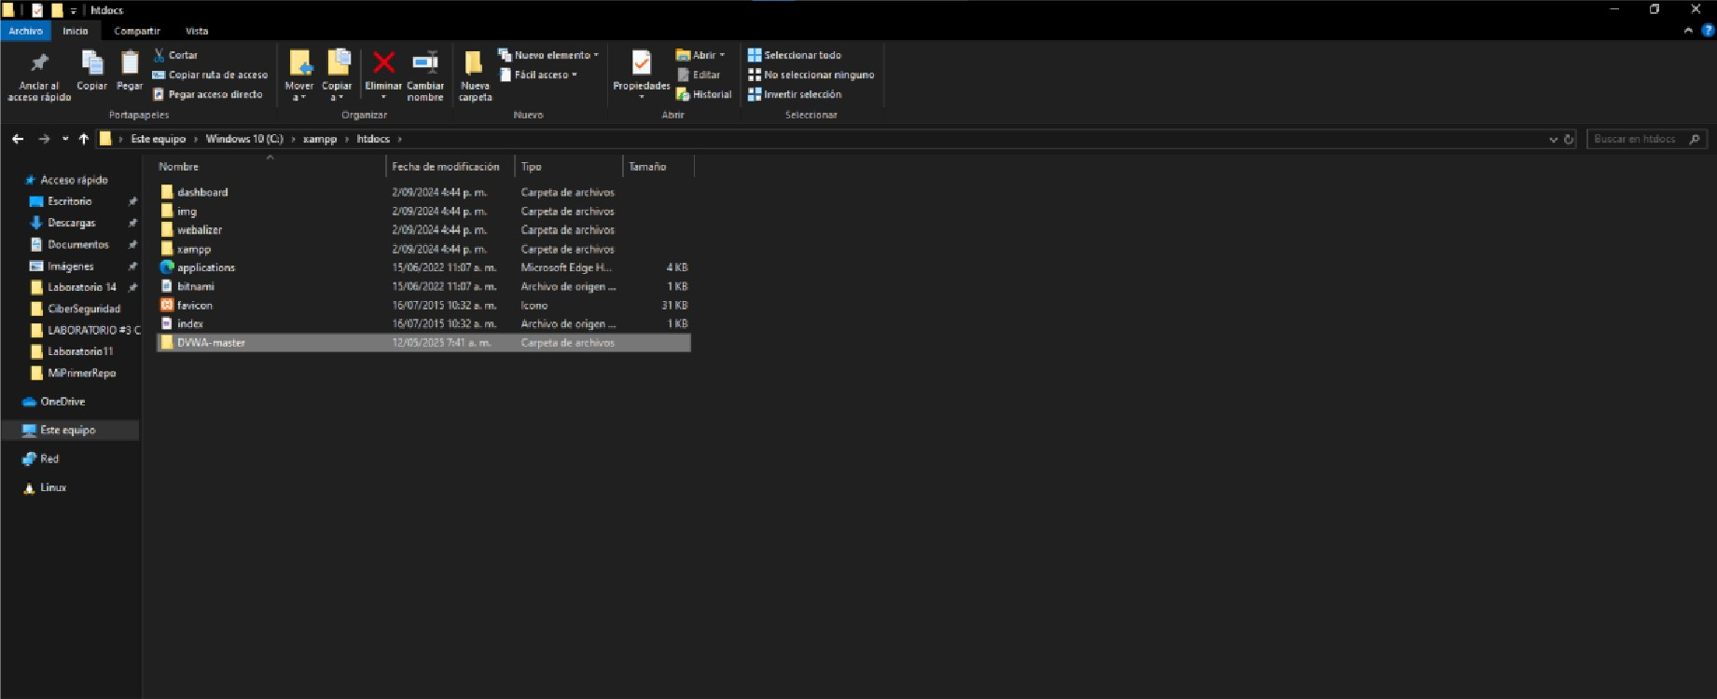

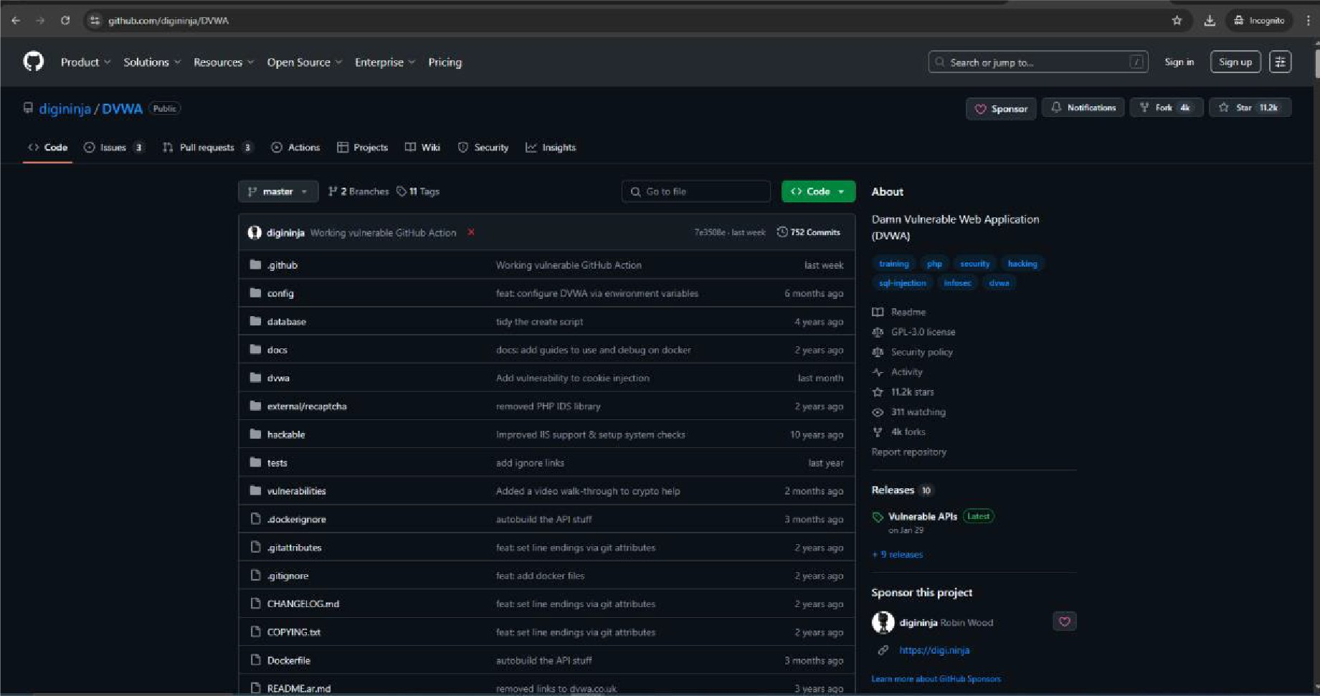

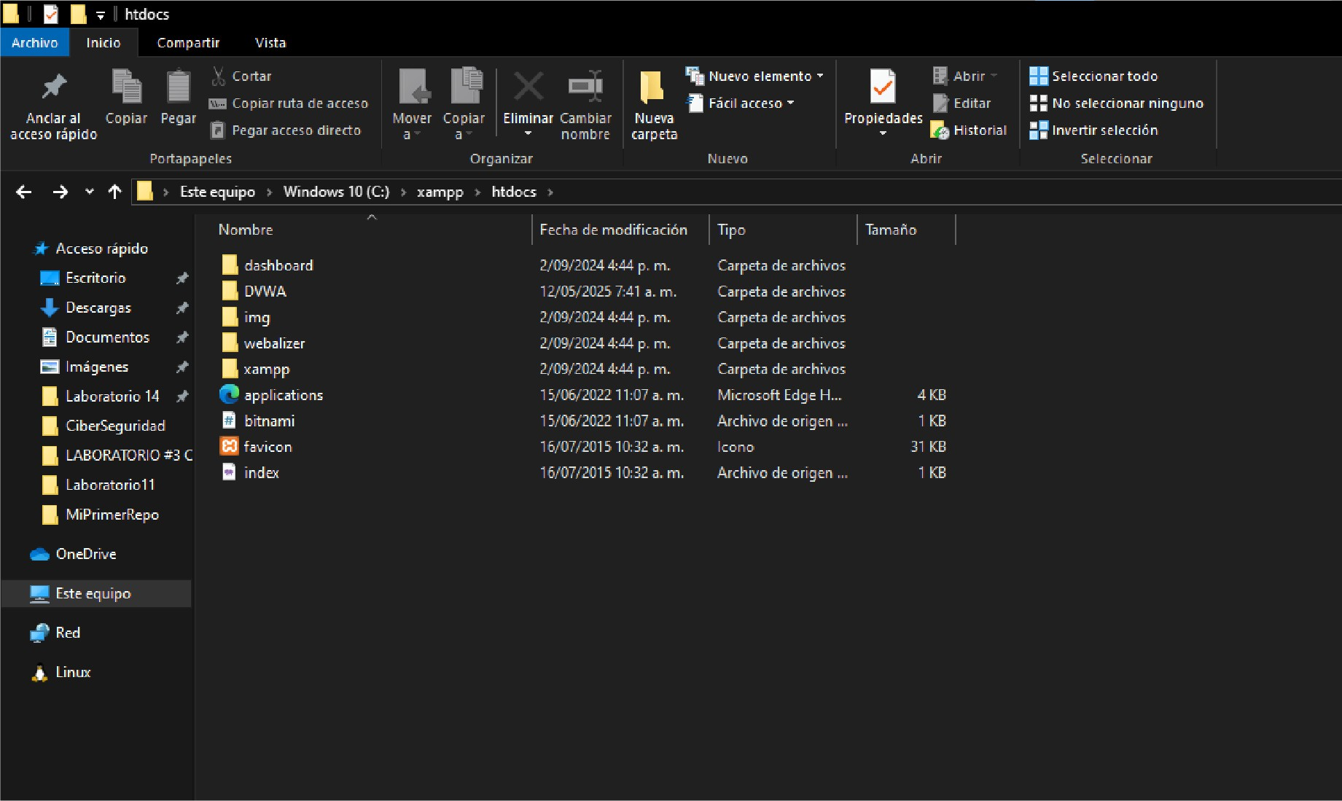

0 lllil uo,,w..., • • *=i* .,.

( J *:.,)* lcr t, , • , ( ,

DVWASfll= emir - coo£, lik IIOf f"ouncl. Copy coof'l.J,'C UK-php.dm toc00Df,'coa.fi1.1DC.pbp mdcOllfil'Jl"C IO )"0\11" m1"UOll!IICld.

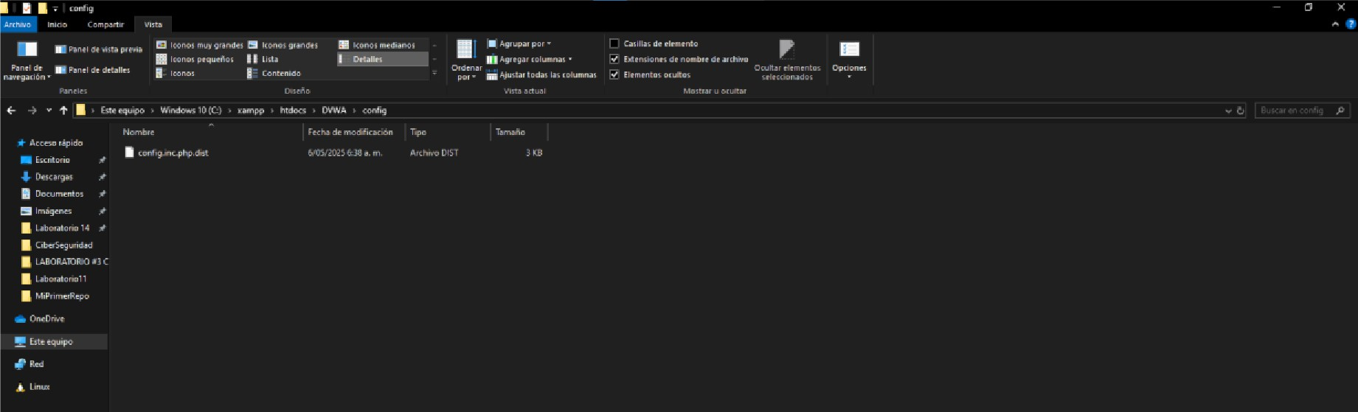

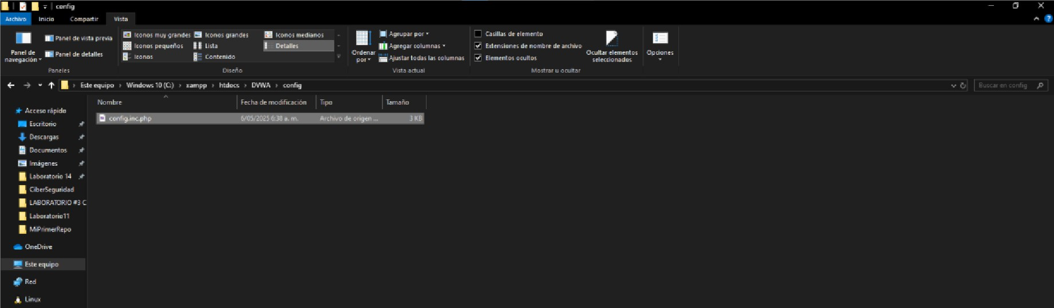

**!""I O *,n*** o,; .. ...,.. ,,Hllllllr-"f'Jlo""' " *-:;1* •

' l • C,,::i"'='ll , "

*pp* **!1"t1s,,...i.;'m 11**

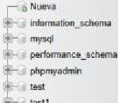



# Bases de datos



### tll!rnt,.i_..,.,_:!_d

**8aw... ......,.** *c...,., ,*

### inlGo'TM!iOfl_KMtM Mtfl....1.,.ral_da p,Mllogia,I

**RI)'** M't .J!-rd_ci • **Se!tu:-pN,ilflglO'!**

**pwfor,nane,,_..-.,• ••d•---1!--••l_d** ■

**pl,pl,,-** f■_l>l.R ■ **P,**

**0!W** hdru._,-hh_d • **p,M.-,.**

'"""'





-, 0 ' •.it.• "' IP',.,,.,.,. "' , •

IX '-:<! '1 ••

f"'l!Srnirlnr 117'l11 JI!:

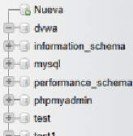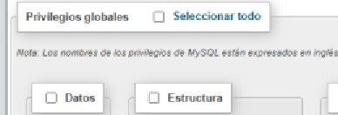

**Agregar cuenta de usuario**

l.'-,ejta,i tlo v 'ffl



doMyS(ll-o•

L::: d- a11c..nu1N:J

0 c,..uNMdtd-wntllMIIIO-,ito'4yotQf9A1todo-1-l,n. 11

0 OIDrilflOOO'llio1 illl!Oml,,w-t.onwi.tOl!'OCN'1(UMnMmo1I_ )

rl OIDrilflOOO'llio1 •19t.>■wlN dvn

0 Admlll!&tr1diln

OsnECT

0 IIISUT

ou-,i **C)mm C)nco**

QCUAU 0(111.0.NT

QALllR Q!iLHR

QINJ!I QPIIOCEU

OIMIJI> 0HLCW>

0 CllAU TEIPCIWl'I' TAILU O

0 YDII 'l'lllol O :iHOW IIATA&.UI

QCllrAUIIDJIINI O LDC[IMLIS

IVJCQJUll5 Pfl flCIJII;

## -, 0 ' _...._, "' IP',.,,.,.,. "' , •

IX '-:<! *n* ••

!1r.i mo11

 

r11"\W<·

f Ml'

=----

!- nlnrmat>Ql>_ ma

r pnpm,,dM1

cun1 _ ........ f'\' lO"MIIFHD VII -i,-1q1_... t!. _,,..,.........,us,,.,·-·-· ;lilLllfT '-"""61 DIii--- rn·-··• - EQUI., MONE Wiffl _q.JE•H _ ·- D "°'- IW(TlDlll5_P£ _ a ....._ H _.. _ e _ l _ [CTI ............

ML P IVIL!VU ON·-.• TD •-••1•1•,

l tlil.lr• hn..,][l<liLl•lli atiO<iy PHl'I

**Editar los privilegios: Cuenta de usuario *'dvwa'@'%'*** - **Base de datos *dvwa***

## Prt.r •lf"Kltlcotipen,labaMINct.1101

## a SH«clonwlOdo

0 SILECT

0 IIISUT

OU-TE f'JDILIT[

## f'JEMRKllll"II

**ci-**

eilLDC[TAll1.IS

e;I HHREIICH

* 0 11:;;l '" _,,,,, · ............ • :.r •
* *:*•II- I ' '



C--Mr::1:'t-•--CMe•

- 0 GI ..., .., ......."'°""" • :.r •

* *:* • ..- •I ,, 1 r *r*



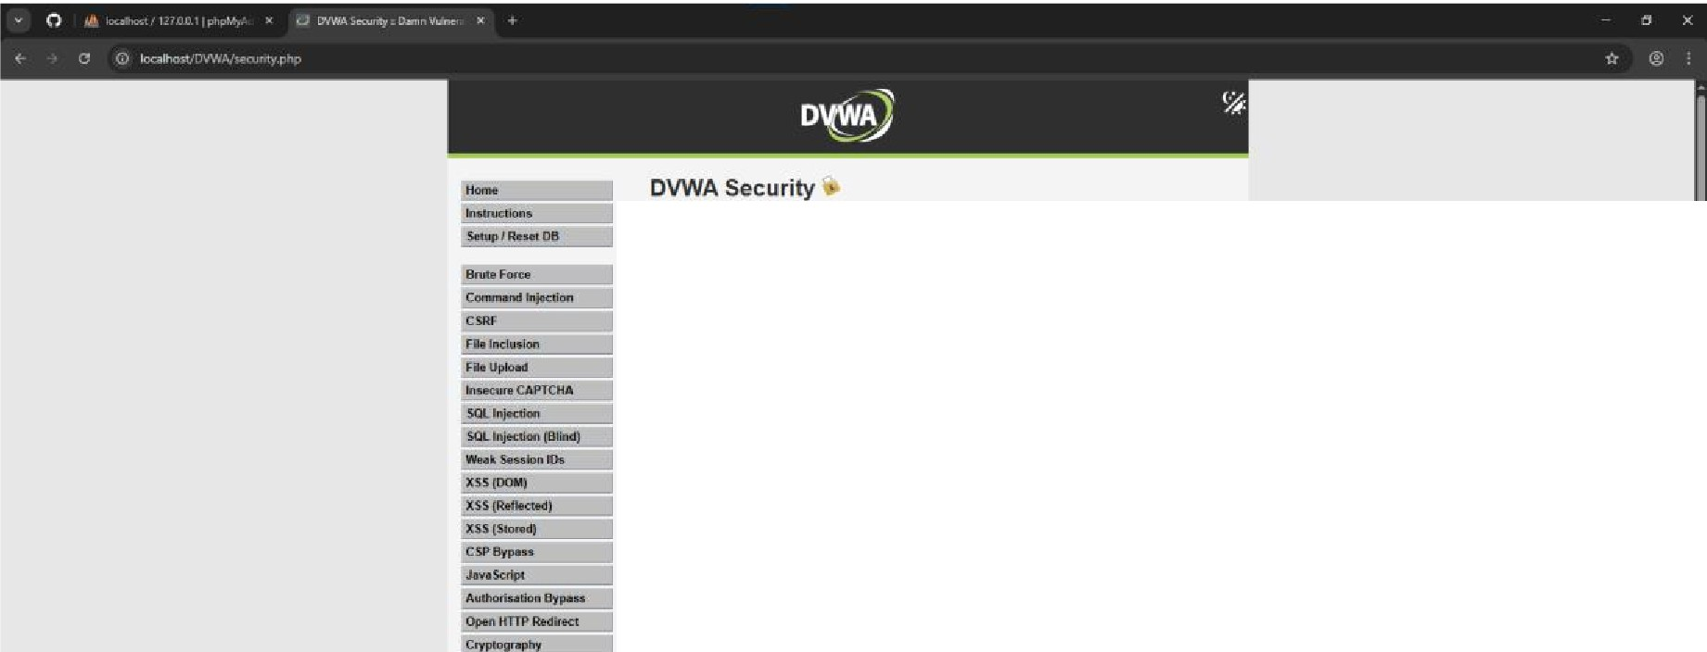

Security Level

s.c...,i.........., ....

y.,.. ,... ._...,.,.....I0.... ..,..,,,,,"9"0<1n_.;t,k,Tt. h.,._abil!v

..,.,ow.A

1 L--Thh_,..'ly ,-i......._.,-- ..... ,.., -..N•lal.rs-i.klbe

a;,nu......ofM",.., liunlOWN<.W....... h-st,tw ""qp,a_. andla-

illlplllllll'l'lllilolflHIIOflilMlr.lilll.: i.dlroqi,K

2.M..tln-Thltl+lm llmwily!O.,. anw.an,:,lai NWM!ofbtdMCVl!qo?fKOl:fl, •N

i-,-tri.;ttuw..i..........llfllil- .- ..........,.....- ..-­

upW.ah

Jtv,•Thk-opior,............, • .i.rwdi,,,r10 ••mlK\llr•ul r<h<"'-"'•marli. ,t.cf

pi'KtkHti:lila.,,,.ptlO-atM(- Th1..-;1t:a)-11111fllo0tmr/1M1-e»&n1ol11'o11

u tlollilrwOl•..tviC-.,,.Tl>t (CTF1)00 1

4np,,lllta-Thil ......M<IUl!lho ..........,.. .......1....,.- •• .- ... ""'11pa.t .. -

.......,cao,,...........""'-"OII .....

Prlu-k>OVWA.-1 _ ........,. _.1;,_,,a'lllgh'

Wlll..tlll1-

u-•IJll'91

=!-tlv,o- 50l.i06:-,,.qi



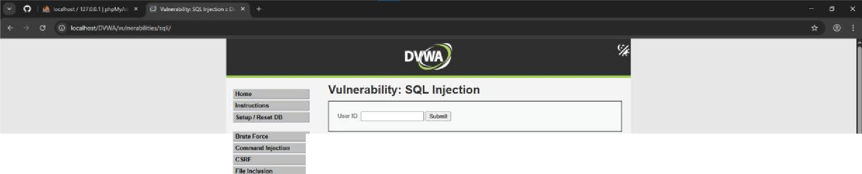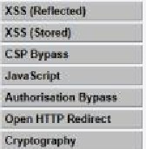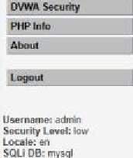

More Information

F.. U. ,

I.9;

.,_,_,.(:APfCHA

SCl. t8iiadl:

W..kSnHOl!Kh

"'""'"

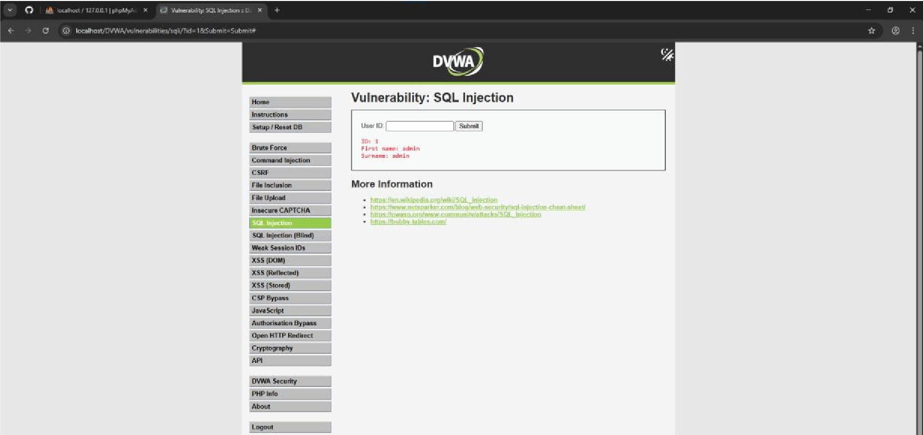

*=*U*.*-=*,,*•*:*!*;*J*,*ni*-*

SOl.i06;-"'1'"'11

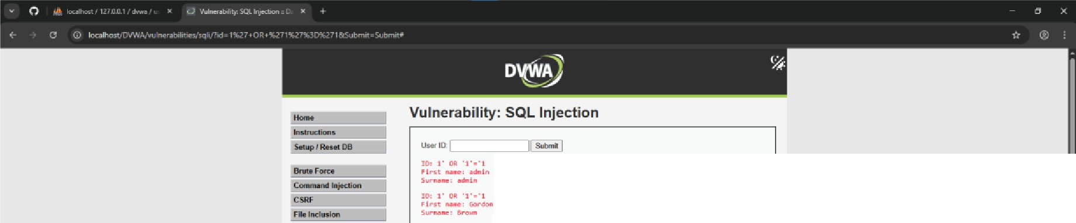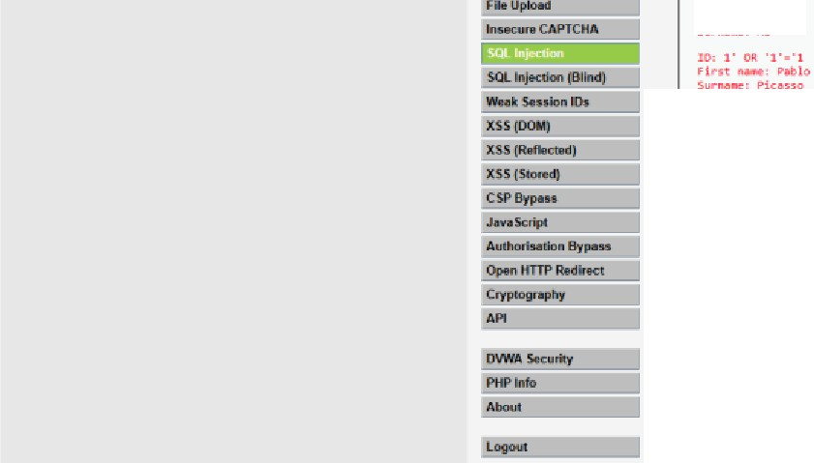

10,1·011·1·■·1

firot.._,14■c,

s ,,..

10: 1· ·1·■·1

sF.,l..r..1,..t-,klC

,.._tth

More Information

·

u ,

SKMlitrlwtl:lcw

LORlt;.,,

§Q(_IOflc

......s,...,. ...........

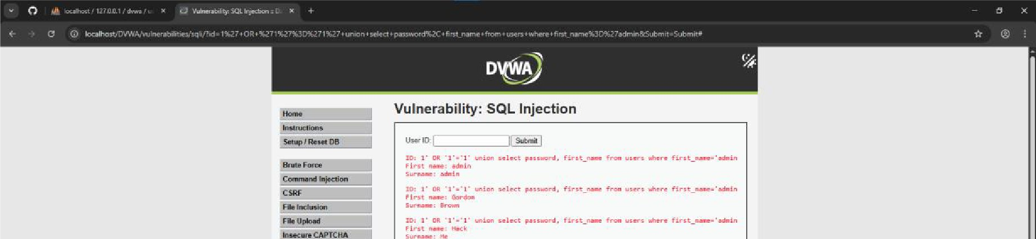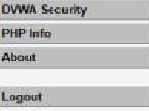

lui.i.,.c-..--i

W.. .s:...IDnO.= XS5

More Information

u--

='!"81a•

SOU09:lfl)'iql

--..-

m

:.,,.,'.•..:.,;i;:i.: .,,,;_.,., ...,1 • ,..,....,n1. ffr•t_,._ f,.,,. ,..r, •.c• f!r,t_,._.•-111

, ........, 1 ......

;';' .:•..:.,, • • ..,..j..., .,.\r.et ,..,_,..,. *fvu_,-* fr,- *...,r,* ""••• firu_--•-1,.

,.,..._,s.-11

:: .!•..:.,;\;;!,;::; :i-:;.!:;: ;= i,:!;••-- f,- •-• ..,...,. ttm_,_·-1

5..,..,..,.. -I

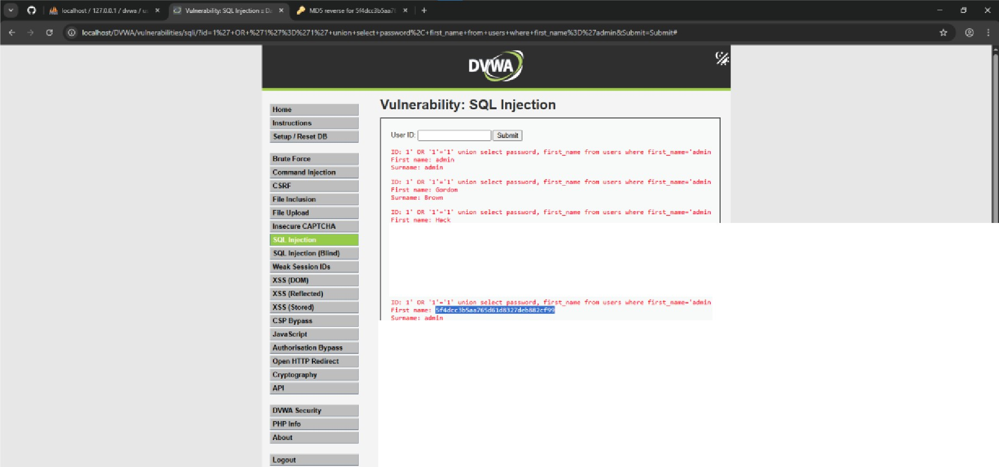

: .:•..:.,:\:.:: .,,.i,,,, ule.ct p.,,....,r,c1, flru_,- f""" user, *,.,<r* ffr1t_..-.•-1 5....,.., io•

;.!·..:.:\.;;e:1· ....1..., HIRCt pH •...,...., Hnt f...,. ·-· ,.,..,.. fint_--·-,

5..--, JI

More Information

., ,..

u--=,.ia,;,,

**.,,._SovJc,o\lin,tWp**

*11rftrl-tklw

50llOfl;lffJS'1I

0 Y' *)* • *CJ* • • ,,..L,!,._..,.,.,,,,4d<.<.Jb,u • t ::I *}'*

( *;:* •, r-•' ,.,..,,....,,-. -.,, ,- • ' I• • *r* • " i• '•"



***MD5 Center***

MD5 WflWl!iilOn aoo rlN9fSII lookup

lccated3mlnutesfromEI ... _-,• ' • - •

_

Corado airport. CDmfDrUble n:ioms. CMvenUon c: u,r

•

**Habitel**

..- ***or*** •

MD5 reverse for 5f4dcc3b5aa765d61d8327deb882cf99

TMMD5nasri,5HClll:3n5aaZ65(16:ta!l. ,assucce;.srulyrn ITTtolheWl'lg

FBQI froo 10 provide !'.OrM olh&f MOS has!18S ';OU woolll:Ikll 10 If'# kl r&Jllrs.11

Sl4dt:t3b$;)&?6Sd6108327deb882ct99

You can oo-,11ra111ff'l(jMl)5 Msn ol 11'19stnf\9 W1'lldl was lf1SI rn to ha\18 tM proot1na, It tS 1118samaas 1M MD5ha!:l1 J'Ollpr · Convett a string to a MOS hnh

"""""''